EXPERIMENT 1: 1) To install the MongoDB server and run the client shell.
Step 1: Custom Setup, in this we can select the way in which we want to install MongoDB.
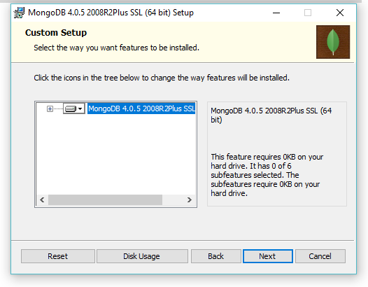
Step 2: Choose if you want the MongoDB as network service or as a local user also it shows you the directory.
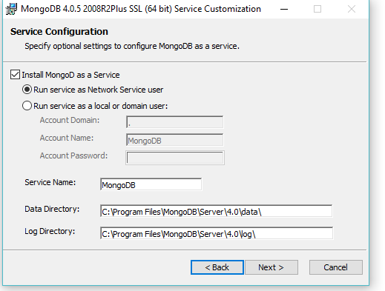

Step 3: Install MongoDB Compass as it is the interface for the same.
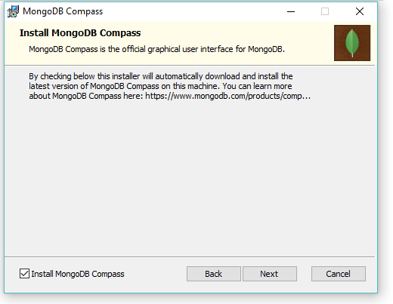
Step 4: Now in order to install MongoDB click on change or if you want some other changes to be done then you can go back and change accordingly.
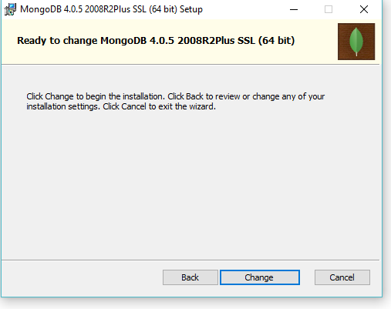
Step 5: In order to setup and to complete the installation click press and it’s done.
